OreSat Thermal Analysis

Product Design Specifications Report - Fall 2018

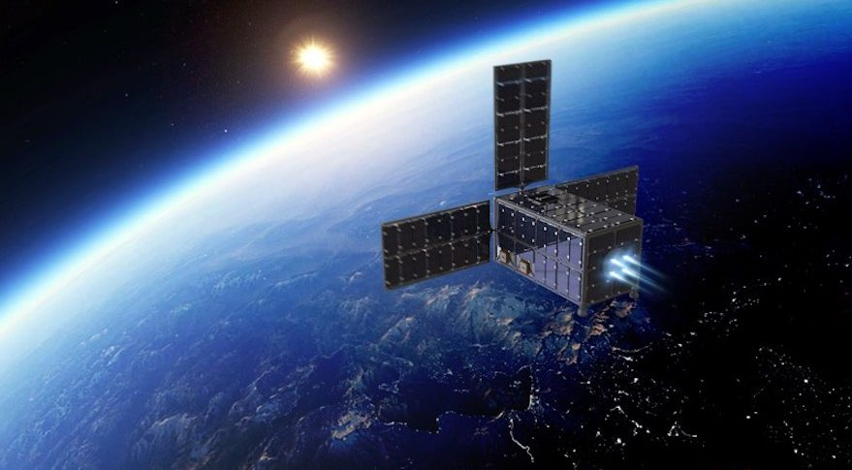

**Capstone Team:**

Parker Southwick

Jeremy Lowman

Katherine Popchock

Thomas Otero

Tyler Benson

Griffin Johnson

**Faculty Advisor**:

Derek Tretheway, PhD

**PSAS Industry Advisor**:

Andrew Greenberg



## Table of Contents

**Intro** **2**

**Explanation** **2**

**Mission Statement** **3**

**Top-level project plan** **3**

**Identification of Customers** **4**

**Customer Interview** **5**

**Customer Requirements** **5**

**Engineering Requirements** **6**

**Product Design Specification** **7**

**Conclusion** **8**

## 

## Intro

OreSat sponsored this capstone project, the purpose of which is to conduct a thermal analysis on their 2U CubeSat and to provide them with actionable suggestions. A CubeSat is a miniaturised (U-class) satellite originally developed in 1999 at California Polytechnic State University for low Earth orbit data collection. The original CubeSat had dimensions of 10x10x10 cubic cm and a mass of 1.33kg. CubeSats are generally made with commercial off-the-shelf components and cost a mere $50,000 per project—a fraction of the cost of large satellites.

OreSat will be Oregon’s first satellite and is backed by NASA’s CubeSat Launch Initiative (CSLI). In exchange for NASA’s support, OreSat will collect data on cirrus clouds. However, to survive in space, the thermal behaviour of the satellite and environment must be understood and mitigated. The goals of this project are a) to observe cirrus clouds in the upper atmosphere of earth, as part of the deal the Portland State Aerospace Society (PSAS) made with the CSLI in exchange for a launch to the International Space Station (ISS) and b) to act as a STEM outreach tool for grade, middle and high school students in Oregon.

## Explanation

OreSat will be transported to the ISS in a temperature-controlled environment and will not produce any heat during this stage. However, once it is launched into space, there are two main phases of motion that will be analyzed.

The first phase is when the satellite is initially launched. During this phase, there will be little to no control of its rotational motion, and the angle of its orbital trajectory around Earth could vary. Here the main goal is to determine the worst combination of these factors and apply that to the model to determine if materials will fail.

The second phase will occur about 45 minutes after launch. At this point there will be control over the satellite’s rotational motion. The satellite will have two modes of heat generation rates; active and passive. Here the goal will be to determining the optimum rotational motion of the satellite, and the best frequency for the active mode to turn on.

## Mission Statement

The capstone team is responsible for creating a thermal simulation in ANSYS of the 2U CubeSat satellite named OreSat. The simulation will be used to determine the thermal state of the CubeSat at different thermal cycles. To verify these results, a prototype of OreSat will be tested in a vacuum chamber. The verified thermal results will then be turned over to the design team of OreSat, along with recommended actionable suggestions for modification of the satellite. Based on these suggestions, the design team will determine which modifications to implement before releasing the satellite to NASA. The deadline for the thermal analysis and actionable suggestions is June 2019.

|  |  |
| --- | --- |
|  |  |
| Figure 1 & 2: Preliminary CAD rendering of thermal simulations of outer CubeSat structure | Figures 3 & 4: Preliminary CAD rendering of thermal simulations of internal OreSat PCBs |

## Top-level project plan

This capstone project has three primary objectives: perform a thermal analysis on the OreSat 2U CubeSat in both active and passive state, determine best/worst case scenarios based on environmental factors, and report actionable suggestions. The timeline for these objectives is detailed below.

|  |  |
| --- | --- |
| 10/01 - 12/31 | Research other CubeSat projects. Simulation setup, assumptions made, thermal contacts, materials used, frame design, etc. Write up a Product Design Specification (PDS). Have a simplified SolidWorks model ready. |
| 1/1 - 2/28 | Initial thermal simulations of the satellite. Create actionable data for the OreSat prototype frame to be tested in the vacuum chamber. |
| 3/1 - 3/31 | Determine temperature fields, including the best case and worst case scenarios. |
| 4/1-4/30 | Suggest an optimal roll rate for the CubeSat. First thermal tests in the vacuum chamber. Critical Design Review (CDR) after the first tests. |
| 5/1 - 5/31 | Suggest any material changes after physical testing in the vacuum chamber. |
| 6/1 - 6/29 | Final documentation. |

Table 1. Timeline for capstone project.

## Identification of Customers

OreSat as a project has numerous stakeholders and customers. Identified below are the primary stakeholders and customers for the thermal analysis capstone.

|  |  |  |  |
| --- | --- | --- | --- |
| Customer ID | Customer | Category | Motivation |
| 1 | Portland State Aeronautical Society-Andrew Greenberg | Primary Stakeholder and Customer | Longevity of satellite for visual transmission |
| 2 | Portland State ME 491/492/493 | Internal Customer | Education and design experience for students |
| 3 | NASA | External Stakeholder and Customer | Longevity of satellite for cirrus cloud data collection |
| 4 | Derek Tretheway | Faculty Advisor | Aid in educational experience for students |
| 5 | Oregon Students | External Customer | Increase STEM outreach for Oregon Students |

Table 2. Outline of primary customers and stakeholders.

## Customer Interview

The interview with Andrew Greenberg, the primary stakeholder and customer, started with him informing the capstone team of OreSat’s mission objectives as a project, then explaining what information was expected from the thermal analysis. First, the capstone must determine the active and passive thermal state of the satellite; as in, when the satellite is operating and when the satellite is in standby mode. Second, the capstone must analyze the environmental effects on the satellite as it orbits Earth, and the best/worst case scenarios during this orbit. Third, Andrew Greenberg requests actionable suggestions based on the prior two requirements. The interview concluded with recommendations from Andrew Greenberg on how to start the analysis process.

## Customer Requirements

|  |  |  |
| --- | --- | --- |
| Req ID | Requirement | Customer ID |
| 1 | Determine thermal state of satellite: passive/active | 1 |
| 2 | Determine best and worst case environments/scenarios | 1 |
| 3 | Determine estimated thermal lifespan of satellite | 1 |
| 4 | Determine roll rate of satellite | 1 |
| 5 | Determine actionable suggestions for heat dissipation | 1 |

Table 3. Description of customer requirements.

## Engineering Requirements

Extracted from the customer requirements are quantifiable engineering requirements. Due to the nature of this analysis, all engineering requirements are performance based.

|  |  |  |  |  |  |  |  |
| --- | --- | --- | --- | --- | --- | --- | --- |
| ENG ID | Design Variable | Ideal | MIN | MAX | Unit | Significance | Customer Requirement |
| 1 | Temperature | 0-60 | -20 | 100 | ℃ | High Importance | 1 |
| 2 | Beta Angle | TBD | -90 | 90 | ° | Moderate Importance | 2 |
| 3 | Lifespan | 43,800 | 1 | 43,800 | hr | High Importance | 1, 3 |

Table 4. Specified engineering requirements based on customer requirements.

The temperature extremum are based on the PCB performance specifications. The ideal temperature range is based on the batteries’ temperature requirements. If the thermal state of the overall system stays within the ideal range, no further action need be taken to protect thermal state of the batteries. Otherwise, design solutions must be considered for the batteries.

With regards to the beta angle, the ideal angle will be determined as outlined in the timeline mentioned above. However, preliminary research indicates the beta angle of the ISS is between -75° and +75°. Barring catastrophe, the OreSat satellite should not reach 90°.

Research has shown most CubeSats die within 30 days. The few which survive past 30 days tend to last for about 4 years. The objective of this capstone is to provide actionable suggestions to achieve at least a 5-year lifespan with regards to thermal failure.

## Product Design Specification

|  |  |
| --- | --- |
| TARGET | DESCRIPTION |
| Thermal Analysis | Determine the optimal rotational rate and post-deployment orientation which will evenly distribute the heat the satellite receives from the sun. The goal is to maintain the PCBs on board between -20 and 100° C, and 0 to 60° C for the batteries. |
| Thermal Budget | Calculate the thermal budget for passive and active modes of the satellite. Design simulations to display how the heat generated in both modes is dispersed throughout the satellite. |
| Actionable Design | Present suggestions for product design decisions to create a thermally-efficient 2U CubeSat. The decisions will help optimize heat distribution during standby mode, and thermal sinking during active mode. |
| Test | Build a thermally-correct prototype of OreSat that will be tested for thermal performance. Verifications will be test through the simulation program ANSYS and then compared to results from the vacuum chamber testing. |

## Conclusion

The outcome of the OreSat Thermal Analysis project is critical for a successful launch of Oregon’s first satellite. Accurate simplifications of the model and a well-designed computer analysis will help garner a successful vacuum chamber verification and meaningful data. The critical analysis of this data and resulting recommendations will be provided to the customer, hopefully leading to a successful satellite that will act as a data collector for NASA and a unique STEM outreach tool.